f | استمارة تقييم بحث طلابي | 
كلية الحاسبات والذكاء الاصطناعي | الفصل الدراسي الثاني للعام الجامعي 2019/2020 | جامعة بنهـــــا

أولا بيانات الطالب (تملأ بمعرفة الطالب)
اسم الطالب : محمود رضا حسنين محمودالطباخ رقم الجلوس:1429
البريد الإلكتروني الأكاديمي: mahmoud192536@fci.bu.edu.eg
اسم البرنامج الدراسي/ القسم: عام
المستوى/الفرقة: الاولي
ثانيا بيانات البحث (تملأ بمعرفة الطالب)
اسم المقرر: Probability and Statistics
اسم أستاذ المقرر: Dr. Ahmed Hagag
عنوان موضوع البحث:Sports
رقم الموضوع (إن وجد)Topic No. 5
ثالثا تقييم البحث بمعرفة لجنة الممتحنين
هل البحث منقول؟ □ نعم □ لا
في حالة ان الإجابة بنعم لا يتم تقييم البحث ويعتبر تقييم الطالب في البحث لم يجتاز
م | عناصر التقييم | الوزن النسبي | مقبول | غير مقبول
1 | الشكل العام للرسالة البحثية | 10
2 | يحقق المتطلبات العلمية المطلوبة | 70
3 | يذكر المصادر والمراجع العلمية | 10
4 | الصياغة اللغوية واسلوب الكتابة جيد | 10
رابعا نتيجة التقييم النهائي
اجتاز | لم يجتاز | توقيع لجنة التقييم
- ...........................................................
- ...........................................................
- ...........................................................
** يرجى التأكد من الا تزيد هذه الاستمارة بعد استكمال البيانات عن صفحة واحدة فقط
f |  | 
Benha University |  | Faculty of Computers & Artificial Intelligence

Research Project Title

A research project submitted
in partial fulfillment of the requirements for passing
the 2nd semester 2020 evaluation

In
Probability and Statistics

by
Mahmoud Reda Hussanin Mahmoud El Tabakh(1429)

Supervised by
Dr. Ahmed Hagag

June 2020

Table of Contents

1. Introduction (Heading 1) ii
2. Content 1
2.1 Subtitle 1 (Heading 2) 1
2.3 Equations 2
3. Conclusion 3
References 4

Introduction (The importance of probabilities and statistics in our lives )

The science of probability and statistics are an essential branch of applied mathematics. They are closely related to everything that surrounds us in our modern daily life.
These two sciences are the core and foundation of the foundations of modern science, and without them, many aspects of our lives would have been absent from us: computers, communications, money and business, weather forecasts, and even ... football matches.
Probability is a mathematical science that tries to quantify how it relates to experiments and tests whose outcome cannot be predicted inevitably before it is conducted, and examples often relate to dice and coins, so probability comes to place a numerical amount that helps predict the outcome of a test (throwing a dice or piece Cash) before doing the experiment, meaning we can say it's the science of predicting the outcome
As for statistics, it is a mathematical science concerned with data in terms of the mechanism of collecting, organizing, analyzing and showing it ... So it is the science of dealing with data.
Probability and statistics provide a mechanism for predicting the existence of a link between different physical phenomena, such as providing a link between the rise in weather temperature and the quality of the process of transmitting an image wirelessly, ending in mathematical relationships of "probability" between different variables, which is known as prediction operations.
Statistics are also used in the process of future forecasting by reflecting the reality of the data and the results of its analysis on future periods, as governments use statistical data greatly in counting the population, and knowing the needs associated with them based on the rate of economic or population growth, and there are many and many methods of known statistical methods that are used for forecasting such as (the general trend method) which is a mathematical equation in which sample data is estimated And that is by using the results for statistical inference

Content
Random Variable : a function that assigns a real number to each outcome in the sample space of random experiment. Denoted by an uppercase letter such as X
There are two types of random variables:
- Discrete Random Variable
- Continuous Random Variable
A Discrete Random Variable : a random variable with a finite range.
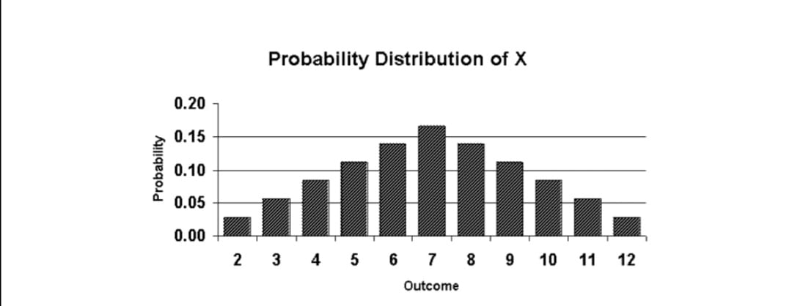
The cumulative distribution function (cdf), denoted by F(x), measures the probability that the random variable X assumes a value less than or equal to x .
The cumulative distribution function is represented by a function F(x)=P(X ≤ x)=∑u ≤ x f(u)
The probability Mass function (Probability Distribution) : a description of a specific random phenomenon in terms of the probability of events occurring
probability mass function is represented by a function f(x)=P(X=x)
Such as Bernnouli Distribution , Binommial Distribution

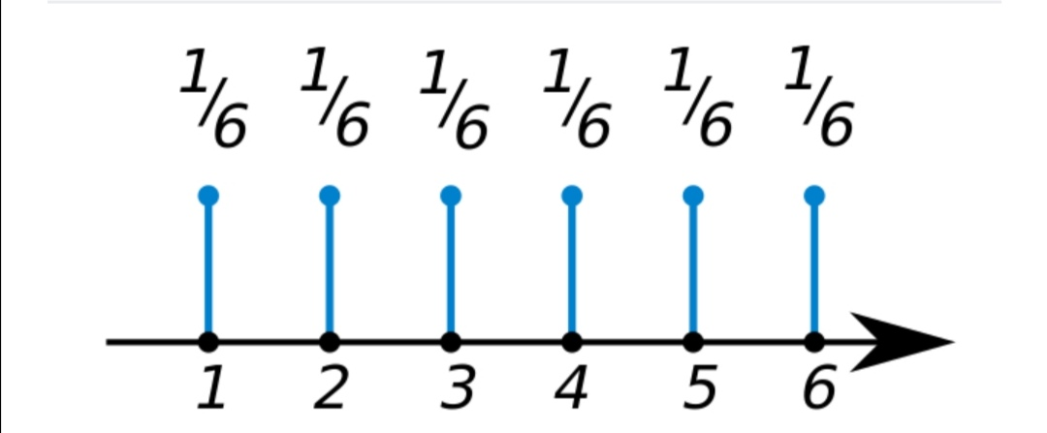
Mean And Variance , Discrete Random Variable
Any finite collection of numbers has a mean and variance.
The mean is a measure of the center or middle of the probability distribution.
The mean of the discrete random variable X is also called the expected value of X.
Properties of Means
If a random variable X is adjusted by multiplying by the value b and adding the value a, then the mean is affected as follows: $μ_{a}$+ bX = a+b$μ_{x}$
The variance is a measure of the dispersion, or variability in the distribute
The Variance of X is denoted by V(X) OR $σ$
Properties of Variances
If a random variable X is adjusted by multiplying by the value b and adding the value a, then the variance is affected as follows: $σ_{x}^{2}$ + bX = $b^{2}σ^{2}$
Standard Deviation is square root of variance. It is a measure of the extent to which data varies from the mean.
Probability distributions with equal means but different variances.
Two probability distributions can differ even though they have identical means and variances.
The mean of a probability distribution is nothing more than its expected value.
For any constants a and b:
Mean 1. E(a) = a, a $∈$ R 2. E(aX + b) = aE (X) + b , a, b $∈$R
Variance 1. V(a) = 0, a $∈$ R 2. V(ax + b) = a?V(X ) , a, b $∈$R
Continuous Random Variable
A continuous random variable is a random variable where the data can take infinitely many values.
A continuous random variable has a probability of 0 of assuming exactly any of its values. Consequently, its probability distribution cannot be given in tabular form.
Continuous random variables are essential to models of statistical physics, where the large number of degrees of freedom in systems mean that many physical properties cannot be predicted exactly in advance but can be well-modeled by continuous distributions.
In particular, quantum mechanical systems often make use of continuous random variables, since physical properties in these cases might not even have definite values.
If X is a continuous random variable, for any x1 and x2
P(x1 $≤$ X$≤$ x2) = P(x1 <X$≤$ x2) = P(x1 $≤$X<x2) = P(x1 <X< x2)
The probability distribution of a continuous random variable is shown by a density curve.
A Probability Density Function (PDF), or density of a continuous random variable: is a function whose value at any given sample or point in the sample space can be interpreted as providing a relative likelihood that the value of the random variable would equal that sample. P(a $≤$ X $≤$ b ) = $\int_{a}^{b}{fX(}x)dx$
If the random variable can be any real number, the probability density function is normalized so that: $\int_{-∞}^{∞}{fX\left(x\right)dx=1}$
Where Definite Integral : $\int_{a}^{b}{f\left(x\right)dx=f\left(b\right)-f(a)}$
The standard normal distribution has probability density: F(x) = $\frac{1}{√2π}e^{-π^{2}/2}$
A Joint Probability Distribution
A Joint Probability Distribution : the probability distribution that defines two random variables simultaneous behavior
The joint probability mass function of the discrete random variables X and Y denoted as $f_{XY}$(x, y).
The marginal distributions of the random variable X alone is: $f_{x}(x)$= $\sum_{y}{f_{XY}}$ (x,y)
The marginal distributions of the random variable Y alone is: $f_{Y}(Y)$= $\sum_{y}{f_{XY}}$ (x,y)
Mean for The Discrete Random Variable X alone is: E(X) = $\sum_{x}{xf_{X}}$(x)
Mean for The Discrete Random Variable Y alone is: E(Y) =$\sum_{y}{yf_{Y}}$(y)
Variance for The Discrete Random Variable X alone is:
V(X) = E(X²) –${(E(X)) }^{2}$ and s.d. of X = $σx$= $\sqrt{V(X) }$
Variance for The Discrete Random Variable Y alone is:
V(Y) = E(Y²) – ${(E(Y))}^{2}$ and s.d. of Y = $σ$y = $\sqrt{V(Y)}$
The joint probability distribution can be expressed either in terms of a joint cumulative distribution function or in terms of a joint probability density function or joint probability mass function
The joint probability density function of the Continuous random variables X and Y denoted as $f_{XY}$(x, y).
The marginal distributions of the random variable 𝑋 alone is: $f_{x}$(x)= $\int_{-∞}^{∞}{f_{XY}}$(x,y) dy
The marginal distributions of the random variable 𝑌 alone is: $f_{y}$(y)= $\int_{-∞}^{∞}{f_{XY}}$(x,y) dx
Mean for the Continuous random variable 𝑋 alone is: E(X) = $\int_{-∞}^{∞}{\int_{-∞}^{∞}{xf_{XY}}}$ (x,y ) dydx
Mean for the Continuous random variable 𝑌 alone is: E(Y) = $\int_{-∞}^{∞}{\int_{-∞}^{∞}{yf_{XY}}}$ (x,y ) dydx
Variance for the Continuous random variable 𝑋 alone is:
V(X) = E( $X^{2}$ )- ${(E\left(X\right))}^{2}$ And s.d of x =$σ_{x}$=$\sqrt{V(x)}$
Variance for the Continuous random variable 𝑌 alone is:
V(Y) = E( $Y^{2}$ )- ${(E\left(Y\right))}^{2}$ And s.d of y =$σ_{y}$=$\sqrt{V(y)}$
Standard Distribution
The standard normal distribution is a normal distribution with a mean of zero and standard deviation of 1.
The standard normal distribution is centered at zero and the degree to which a given measurement deviates from the mean is given by the standard deviation. 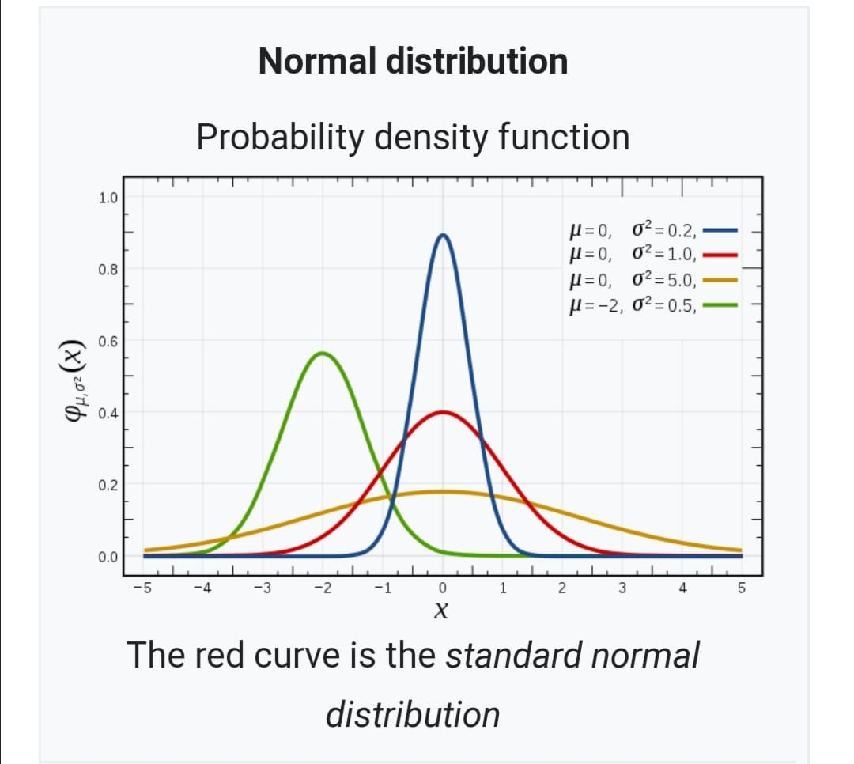
Distribution is called a standard score or a z score. Every normal random variable X can be transformed into a z score via the following equation: z = (X - μ) / σ

Equations

Probability mass function
- F( $x_{i}$ ) $≥$ 0 $\sum_{I=1}^{n}{f(} x_{i}$ ) =1 F( $x_{i}$ )= p(X= x)
Cumulative Distribution function
(2) f(x) = p ( X $≤$ x ) =$\sum_{x_{i ≤ x}}{F( x_{i} )}$
The Mean of discrete random variable (x)
- $μ= E\left(x\right)= \sum_{x}{xF( x )}$
The Variance of ( x) (4) $σ^{2}$ = V(x) = E ($x^{2}$ )- ${(E\left(x\right))}^{2}$
The Standard deviation of (X) (5) $σ=$ $\sqrt{σ^{2} }$
Probability Density function
- F(x) $≥$ 0 $\int_{-∞}^{∞}{f\left(x\right)dx=1}$ p( a$≤$x$≤$b ) = $\int_{a}^{b}{f\left(x\right)dx}$
Cumulative Distribution function
- F(x)= p( X$≤$x )= $\int_{-∞}^{x}{f\left(u\right)du}$ For -$∞$ $<$ x $< ∞$
The Mean of Continuous random variable (x)
(8) $μ= E\left(x\right)=$ $\int_{-∞}^{∞}{xf\left(x\right)dx}$
The Variance of ( x) $\left(9\right) { σ}^{2}$ = V(x) = $\int_{-∞}^{∞}{x^{2}f\left(x\right)dx- { μ}^{2}}$
The Standard deviation of (X) (10) $σ=$ $\sqrt{σ^{2} }$
Probability Density from Cumlative Mass (11) f(x)= $\frac{dF(x)}{dx}$
The Conditional probability Distribution Discrete (12) $f_{x|y}$(x) =$\frac{f_{xy}(x,y)}{f_{y}(y)}$
( The Examples )
- The national team won one of the national patches with a result of 9-0, the first player scored 3 goals, the second player scored 4 goals, and the next player scored two goals. calculate the mean and variance of this discrete random variable.

X | 4 | 3 | 2
F(X) | 4/9 | 3/9 | 2/9

X = 5 , 3 , 2
F(4) = 4 / 9
F(3) = 3 / 9 = 1 / 3
F(2) = 2 / 9
mean(µ) = $\sum_{x}{Xf(x)}$ = 16 / 9 + 9 / 9 + 4 / 9 = 29 / 9
Variance ($σ^{2}$) = $\sum_{x}{x^{2}f(x)- μ^{2}}$ = (16*4/9 + 9*3/9 + 4*2/9 ) – 841/81 = 50/81

2) In the statistics of the role, Al-Masry, it was found that each of Al-Ahly and Zamalek team scored 10 goals in the other, in only three games. The first Al-Ahly defeated Al-Zamalek 4-3, the second also Al-Ahly defeated Zamalek 5-2 and the third Al-Zamalek won Al-Ahly 5-1 . calculate the joint probability distribution.
X (goal of ahly) | 4 | 5 | 1
Y (goal of zamalek( | 3 | 2 | 5

Answer
X / Y | 4 | 5 | 1
3 | 1/3 | 0 | 0
2 | 0 | 1/3 | 0
5 | 0 | 0 | 1/3

3)In a recent little league softball game, each player went to bat 4 times. The number of hits made by each player is described by the following probability distribution.
Number of hits , x | Probability , p(x)
0 | 0.10
1 | 0.20
2 | 0.30
3 | 0.25
4 | 0.15

The Answer
The mean of the probability Distribution is 2.15 , as defined by the following equation.
E(X) = $\sum{( x_{i}*p\left(x_{i}\right))}$
E(X) =0*0.10 + 1*0.20 + 2*0.30 + 3*0.25 + 4*0.15 + =2.15

4)Twenty balls were randomly chosen to throw them into the basket. The first 8-core was diagnosed. Standard distribution

The Answer
N=8
F(X)= {$\frac{1}{j-I+1}$ if x $∈$ { i , i+1, i+2 , i+3, i+4 ,……..,J }}
J=8
I=1
F(X)= { $\frac{1}{8}$ if x $∈$ { 25 , 26, 27 , 28,…….., 32 }
$μ$= E (x ) = $\frac{J+1}{2}$ = $\frac{9}{2}$ = 4.5
$σ^{2}$=V(x) =$\frac{(J{-I+1)}^{2}}{12}=\frac{64}{12}$

- Conclusion
Probability, Random Variables, Statistics, and Random Processes: Fundamentals & Applications is a comprehensive undergraduate-level textbook. With its excellent topical coverage, the focus of this book is on the basic principles and practical applications of the fundamental concepts that are extensively used in various Engineering disciplines as well as in a variety of programs in Life and Social Sciences. The text provides students with the requisite building blocks of knowledge they require to understand and progress in their areas of interest. With a simple, clear-cut style of writing, the intuitive explanations, insightful examples, and practical applications are the hallmarks of this book.
- Most of the text assumes no knowledge of subject matter past first year calculus and linear algebra
- With its independent chapter structure and rich choice of topics, a variety of syllabi for different courses at the junior, senior, and graduate levels can be supported
- A supplemental website includes solutions to about 250 practice problems, lecture slides, and figures and tables from the text
Given its engaging tone, grounded approach, methodically-paced flow, thorough coverage, and flexible structure, Probability, Random Variables, Statistics, and Random Processes: Fundamentals & Applications serves as an essential textbook for courses not only in Electrical Engineering, but also in Computer Engineering, Software Engineering, and Computer Science.

References

[1] Probability & Statistics for Engineers & Scientists NINTH EDITION
[2] Probability and Statistics for Engineers and Scientists FOURTH EDITION Anthony Hayter University of Denver
[3] https://www.ekb.eg/ar/home
[4] https://libgen.is/
[5] https://sci-hub.tw/
[6] https://scholar.google.com/schhp?hl=en&as_sdt=0,5
[7]https://ar.m.wikipedia.org/wiki/%D8%B1%D9%8A%D8%A7%D8%B6%D9%8A%D8%A7%D8%AA_%D9%85%D8%AA%D9%82%D8%B7%D8%B9%D8%A9
[8] http://www.th3professional.com/2018/10/blog-post_85.html?m=1

